A Photomontage of the Russian-Georgia War
The following photographs were taken in and around Gori by a Polish journalist who prefers them
to remain unattributed in order to continue his work.

Gori after bombing
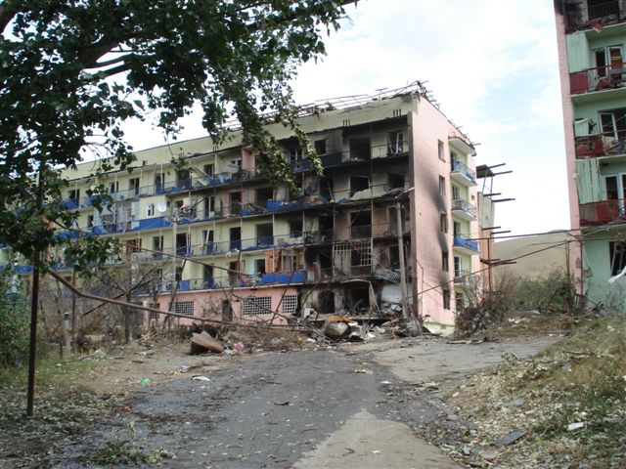
Gori after bombing
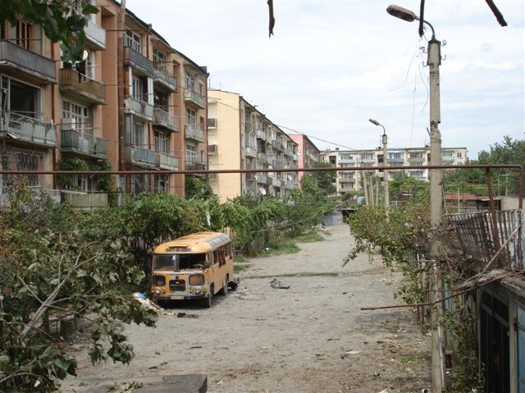
Gori after bombing
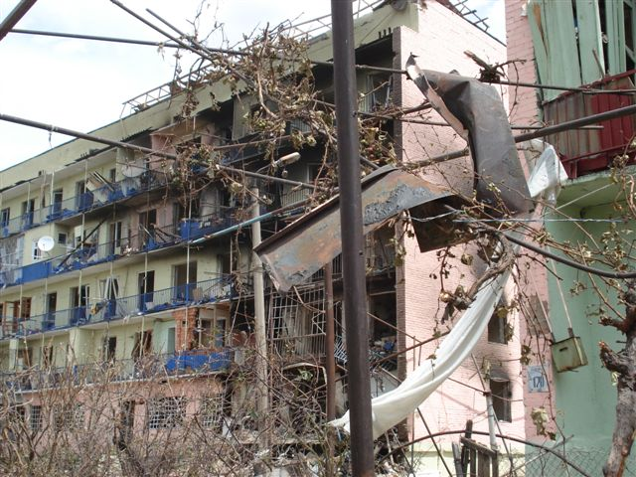
Gori after bombing
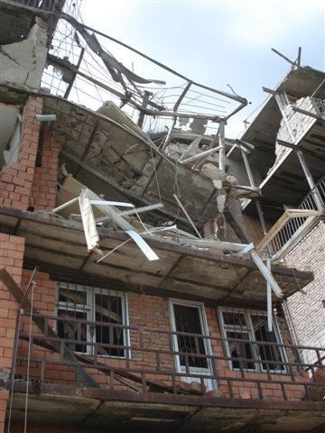
Gori after bombing
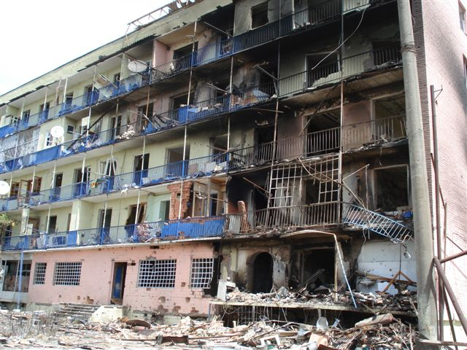
Gori waiting for humanitarian aid
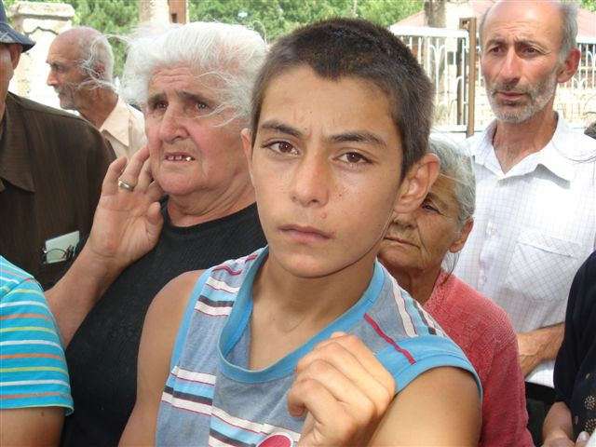
Georgian soldiers
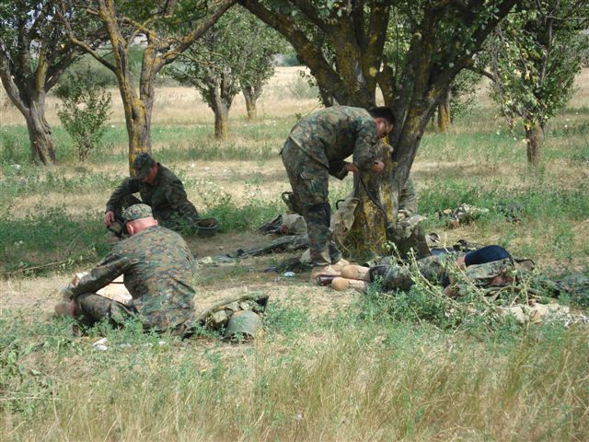
Georgian track
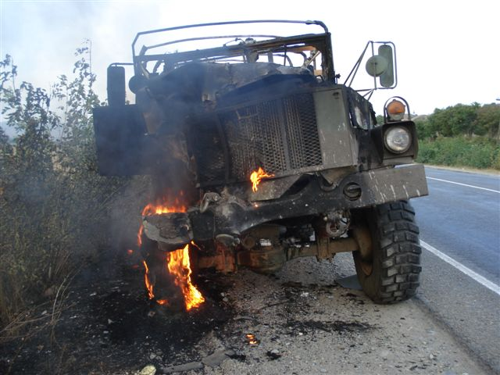
Russian forces coming back to Gori after "visiting" Tibilisi
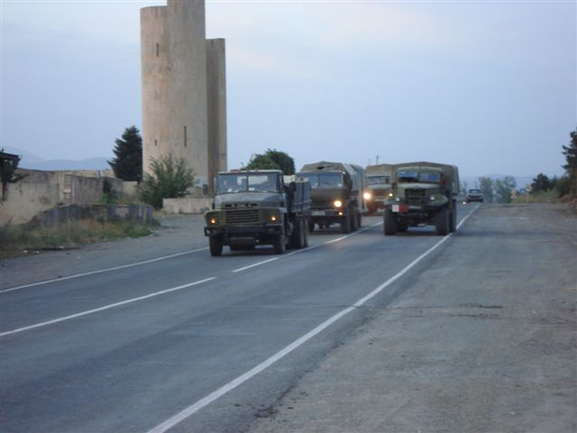

Polish TV operator next to camouflaged Georgian tank
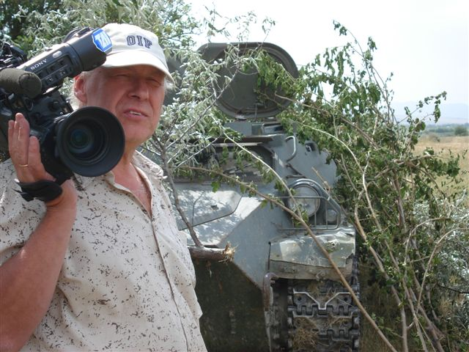

Grasslands in fire - Khashuri region
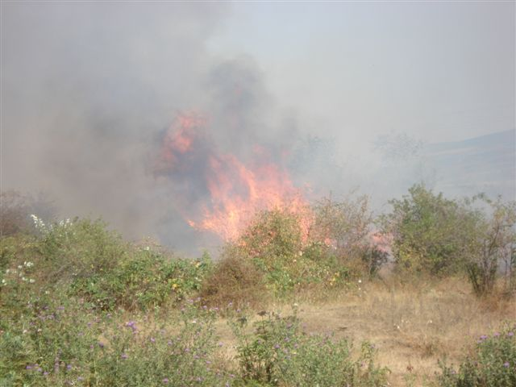

Georgian police station - on the 33 km Gori direction
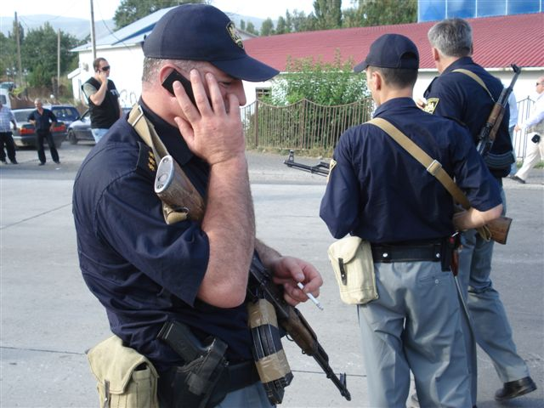
Russian post - Gori - exit to Khashuri
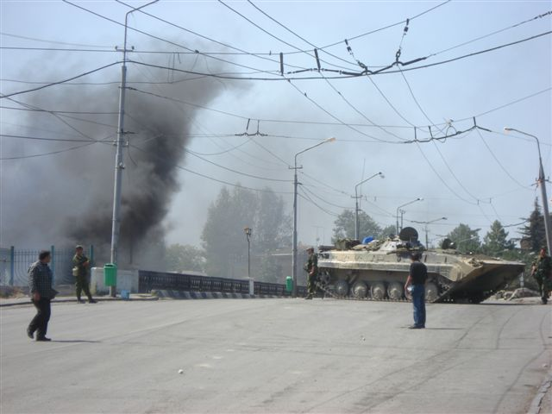
Food relief for Gori citizens
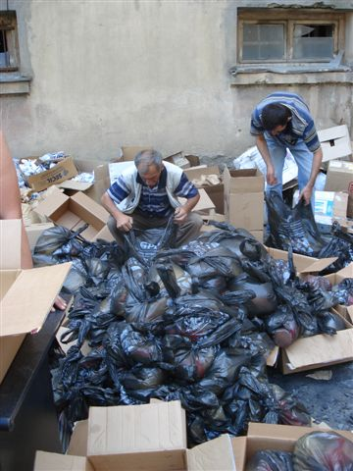
Empty streets of Gori
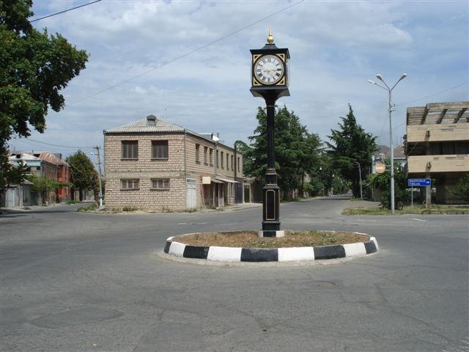
Empty apartment in a block after bombing
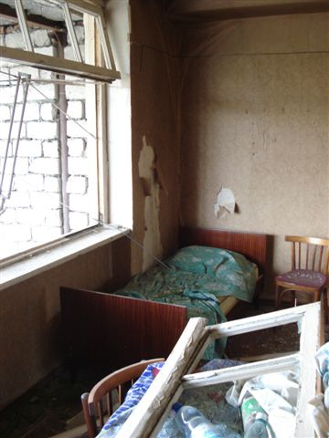

Russian Tank and Soldier in Gori
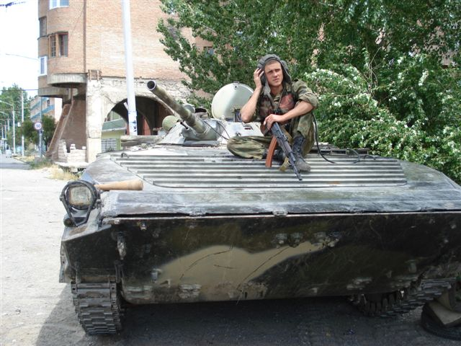
Kkashuri - Tibilisi road - Russian soldiers
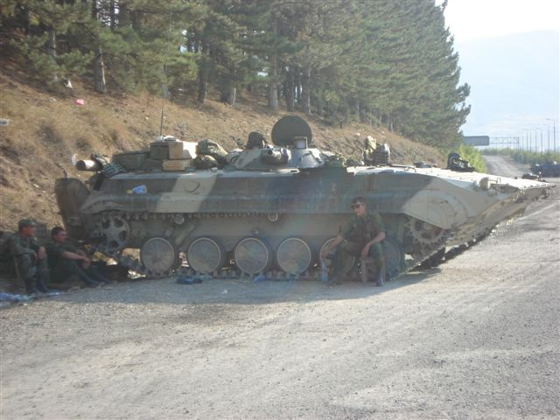
Russian blockade - Gori
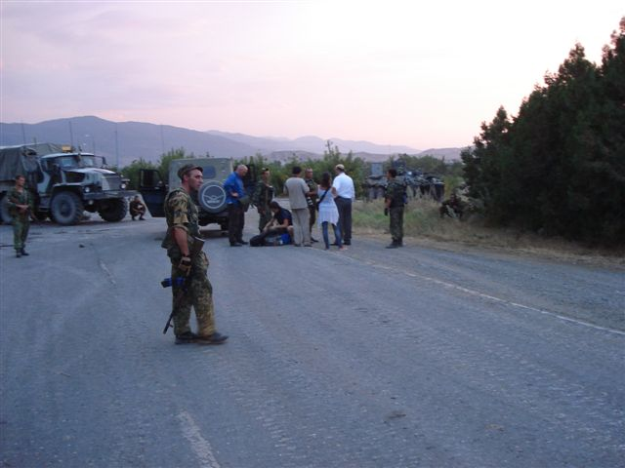
Russian patrol in Gori's streets
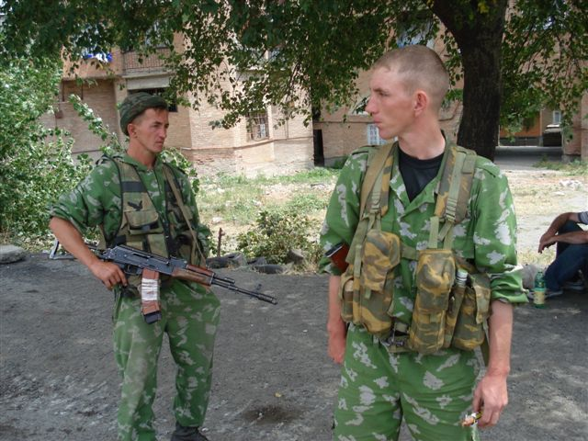
Russian military equipment - Gori, Khashuri
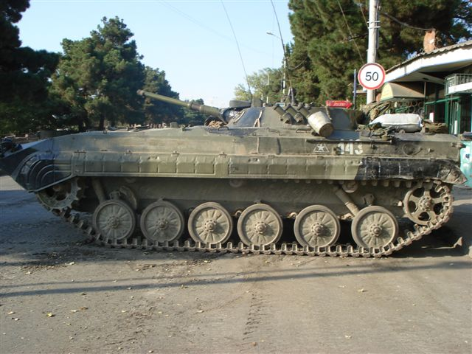
Russian transporter on the way to Gori
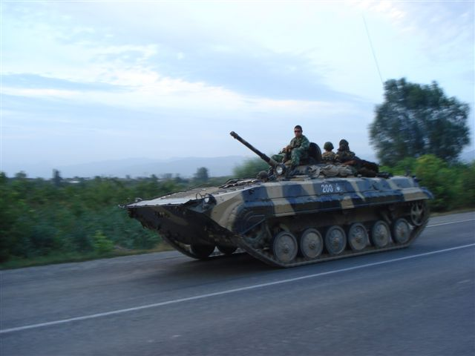
Russian anti-aircraft guns
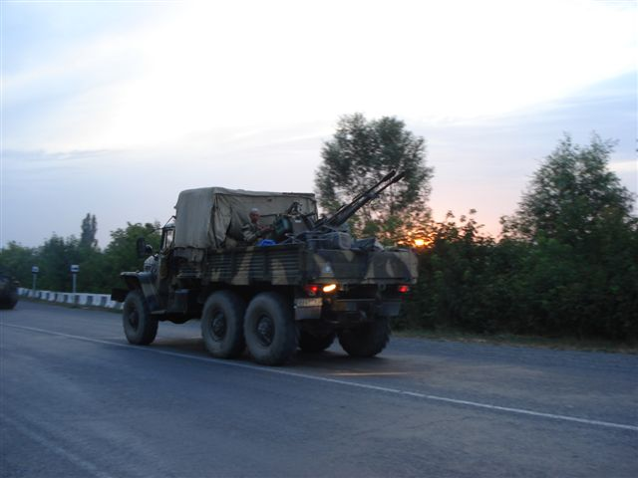
Russian posts closing the entrance to Gori
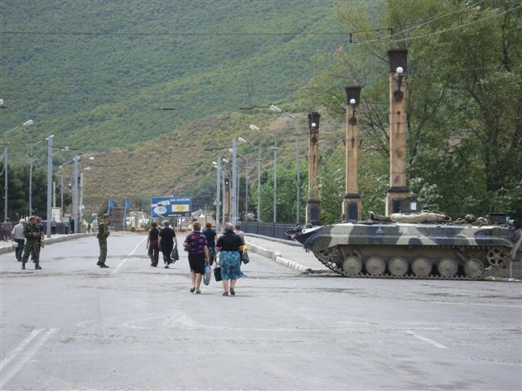
Damaged by shrapnel from the bomb shop-window in Gori - with Stalin's monument in the mirror
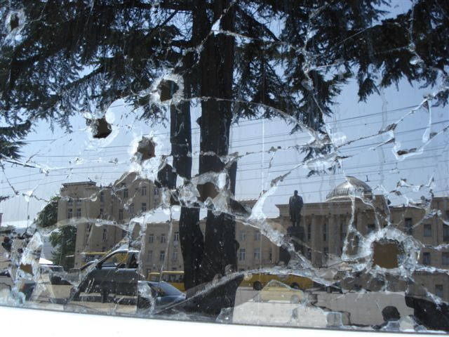
Memorial to Dutch reporter Stan Storiman, killed in battle. The Embassy of Netherlands.
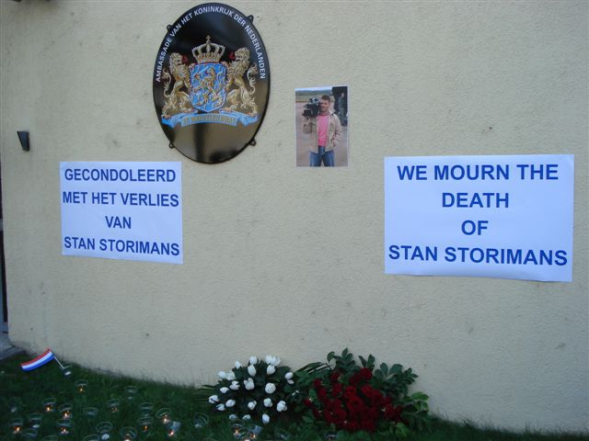
Refugees - Russian army in the background
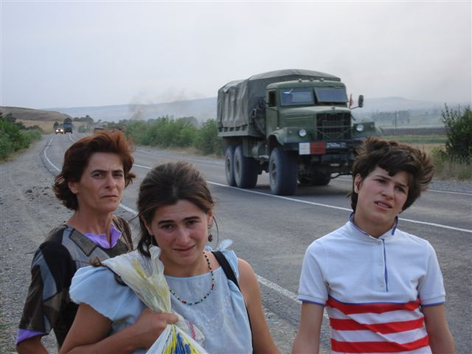
Street in Gori
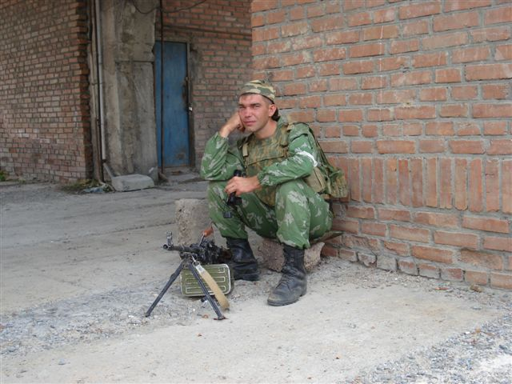
Gori's streets
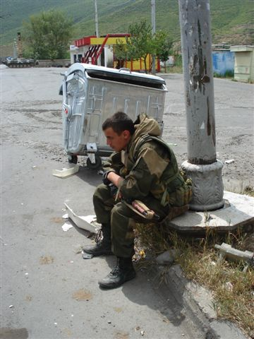
Georgian army on its way to defensive ring
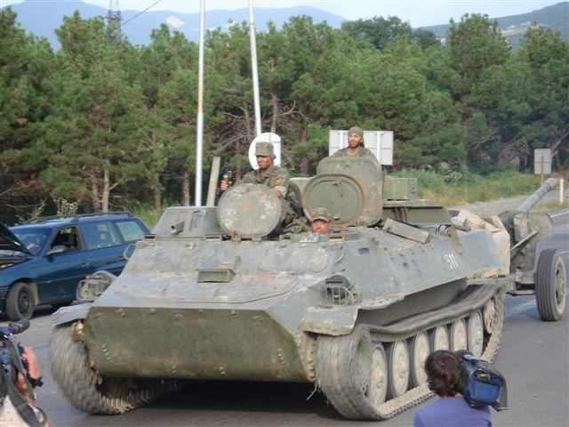
Russian army coming back to Gori


